Lab Manual

of

full stack web development

tcs -693

Graphic Era University

Dehradun, Uttarakhand

Department of Computer science

and

ENGINEERING

NAME: Nikhil Rai ROLL NO: 34

UNIVERSITY ROLL NO: 2014660 SECTION : G

**WEB DEVLOPMENT ASSIGNMENT - 1**

Q1.Write the HTML code for the following Table and write some text in each cell.

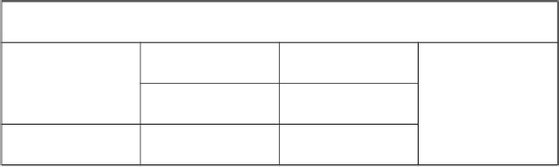

a)

<!DOCTYPE html>

<html>

<head>

<title> Q1.a </title>

<style>

table,th,td{

width: 500px;

border: 1px solid black;

border-collapse: collapse;

}

td{

text-align: center;

}

tr{

height: 100px;

}

</style>

</head>

<body>

<table>

<tr>

<th colspan = "4"> Demo Table </th>

</tr>

<tr>

<th rowspan="2"> Contact </th>

<td> 6256614 </td>

<td> 6669436 </td>

<td rowspan="3"> Empty block </td>

</tr>

<tr>

<td> 656944 </td>

<td> 566646 </td>

</tr>

<tr>

<td> Demo text </td>

<td> Demo text </td>

<td> Demo text </td>

</tr>

</table>

</body>

</html>

**Output**

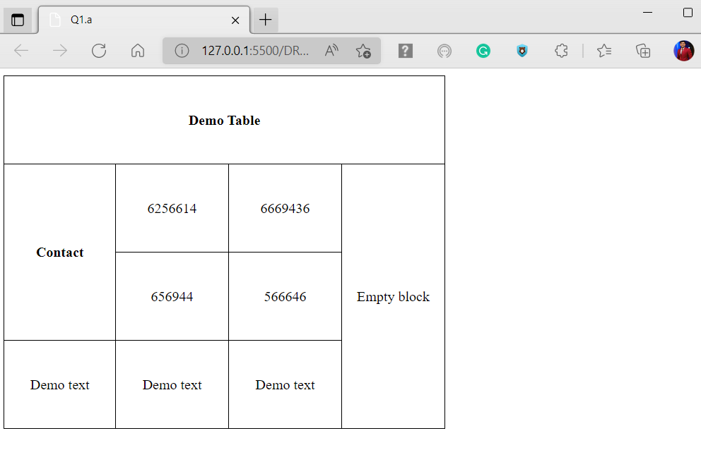

b)

|  |  |  |  |  |  |  |  |  |  |
| --- | --- | --- | --- | --- | --- | --- | --- | --- | --- |
|  | | | | | | | | | |
|  | | | |  | | | | | |
|  | |  | |  | |  | |  | |
|  | |  | |  | |
|  | |  | |  | |
|  |  | |  | |  | |  | |  |

<!DOCTYPE html>

<html>

<head>

<title> Q1.B </title>

<style>

table,tr,td,th{

width: 500px;

height: 100px;

border: 1px solid black;

border-collapse: collapse;

text-align: center;

}

</style>

</head>

<body>

<table>

<tr>

<th colspan="10"> Demo Table </th>

</tr>

<tr>

<td colspan="4"> Text </td>

<td colspan="6"> Text </td>

</tr>

<tr>

<th colspan="2" rowspan="3"> Text </th>

<td colspan="2"> Text </td>

<td colspan="2"> Text </td>

<td colspan="2"> Text </td>

<td colspan="2" rowspan="3"> Text </td>

</tr>

<tr>

<td colspan="2"> Text </td>

<td colspan="2"> Text </td>

<td colspan="2"> Text </td>

</tr>

<tr>

<td colspan="2"> Text </td>

<td colspan="2"> Text </td>

<td colspan="2"> Text </td>

</tr>

<tr>

<td> Text </td>

<td colspan="2"> Text </td>

<td colspan="2"> Text </td>

<td colspan="2"> Text </td>

<td colspan="2"> Text </td>

<td> Text </td>

</tr>

</table>

</body>

</html>

**Output**

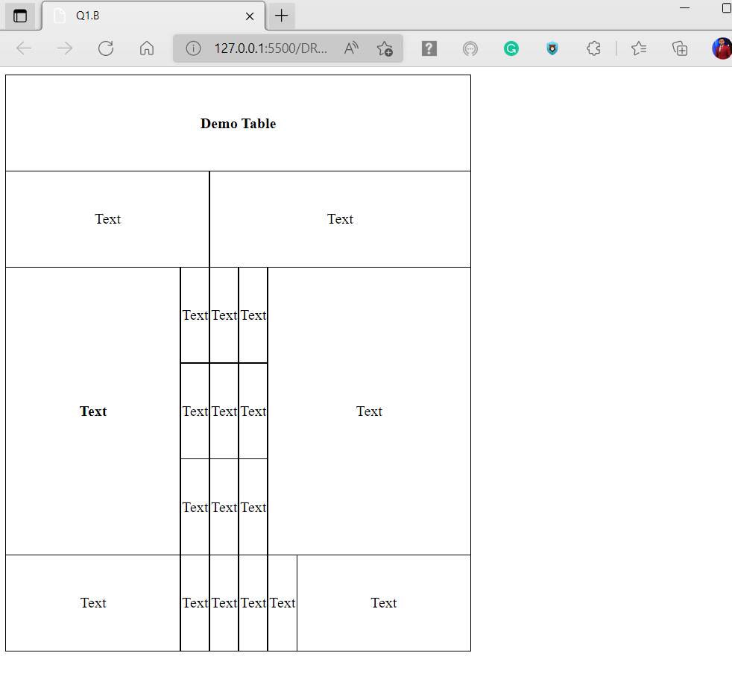

Q2.Write the HTML code for the following Table.

<!DOCTYPE html>

<html>

<head>

<title> Q2 </title>

<style>

table,th,td{

border: 1px solid black;

text-align: center;

}

</style>

</head>

<body>

<table>

<caption><b>Specification of Tables with Hours and marks</b></caption>

<tr>

<th rowspan="2"> Unit No. </th>

<th rowspan="2"> Unit Title </th>

<th rowspan="2"> Teaching Hours </th>

<th colspan="4"> Distribution of Theroy Marks </th>

</tr>

<tr>

<td> R Level </td>

<td> U Level </td>

<td> A Level </td>

<td> Total Marks </td>

</tr>

<tr>

<td>I</td>

<td style="text-align: left">Introduction to Internet Technology</td>

<td>2</td>

<td>4</td>

<td>4</td>

<td>0</td>

<td>8</td>

</tr>

<tr>

<td>II</td>

<td style="text-align: left">Basics to HTML &amp; CSS</td>

<td>6</td>

<td>0</td>

<td>2</td>

<td>6</td>

<td>8</td>

</tr>

<tr>

<td>III</td>

<td style="text-align: left">Active Server Pages 3.0</td>

<td>6</td>

<td>4</td>

<td>8</td>

<td>0</td>

<td>12</td>

</tr>

<tr>

<td>IV</td>

<td style="text-align: left">Server Side Coding with VBScript and XML</td>

<td>8</td>

<td>2</td>

<td>4</td>

<td>8</td>

<td>14</td>

</tr>

<tr>

<td>V</td>

<td style="text-align: left">ASP Objects &amp; Components</td>

<td>10</td>

<td>4</td>

<td>4</td>

<td>6</td>

<td>14</td>

</tr>

<tr>

<td>VI</td>

<td style="text-align: left">Accessing database with ASP &amp; ADO</td>

<td>10</td>

<td>4</td>

<td>4</td>

<td>6</td>

<td>14</td>

</tr>

<tr>

<td></td>

<td><b>Total</b></td>

<td><b>42</b></td>

<td><b>18</b></td>

<td><b>26</b></td>

<td><b>26</b></td>

<td><b>70</b></td>

</tr>

</table>

</body>

</html>

**Output**

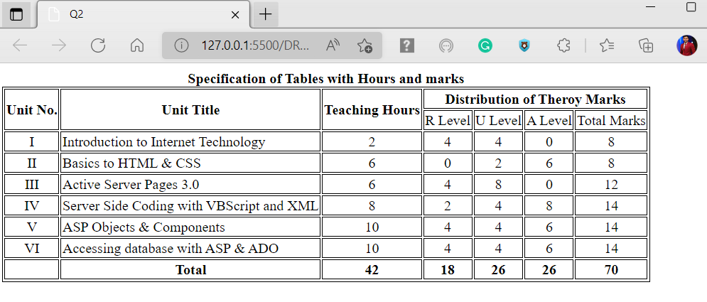

Q3.Write the HTML code, which defines all the formatting tags of HTML in tabular format.

<!DOCTYPE html>

<html>

<head>

<title>Q3</title>

<style>

table,th,td{

border: 1px solid black;

}

</style>

</head>

<body>

<table>

<tr>

<th style="text-align: center"> HTML Tag</th>

<th style="text-align: center">Output</th>

</tr>

<tr>

<td>normal text </td>

<td>hello world </td>

</tr>

<tr>

<td>Font &amp; its attributes </td>

<td style="color: aqua;font-family: monospace">hello world </td>

</tr>

<tr>

<td>&lt;B&gt; </td>

<td><b> Bold</b></td>

</tr>

<tr>

<td>&lt;I&gt;</td>

<td><i>Italic</i></td>

</tr>

<tr>

<td>&lt;U&gt;</td>

<td><u>Underline</u></td>

</tr>

<tr>

<td>&lt;EM&gt;</td>

<td><em>Emphasis</em></td>

</tr>

<tr>

<td>&lt;STRONG&gt;</td>

<td><strong>Strong</strong></td>

</tr>

<tr>

<td>&lt;TELETYPE&gt;</td>

<td><teletype>Teletype</teletype></td>

</tr>

<tr>

<td>&lt;CITE&gt;</td>

<td><cite>Citation</cite></td>

</tr>

<tr>

<td>&lt;STRIKE&gt;</td>

<td><strike>strike through text</strike></td>

</tr>

<tr>

<td>&lt;BIG&gt;</td>

<td><big>text in big font</big></td>

</tr>

<tr>

<td>&lt;SMALL&gt;</td>

<td><small>text in small font</small></td>

</tr>

<tr>

<td>&lt;SUB&gt;</td>

<td>a<sub>b</sub></td>

</tr>

<tr>

<td>&lt;SUP&gt;</td>

<td> a<sup>b</sup></td>

</tr>

</table>

</body>

</html>

**Output**

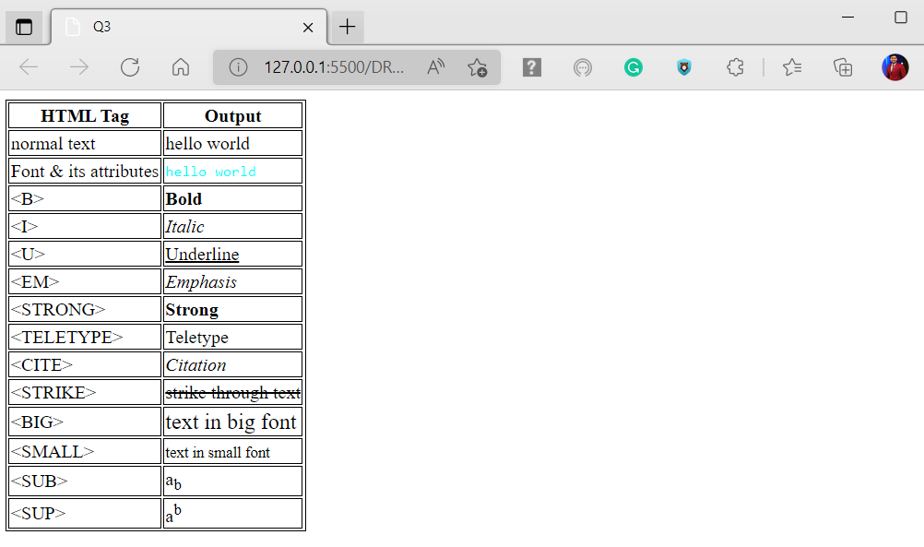

Q4. Write the HTML code to display Uttarakhand map and also display districts detail after clicking on particular district.

<!DOCTYPE html>

<html>

<head>

<title>Q4</title>

</head>

<body>

<img src="uttarakhanddistrict-map.jpg" usemap="#image-map">

<map name="image-map">

<area target="_blank" alt="Chamoli" title="Chamoli" href="https://en.wikipedia.org/wiki/Chamoli_district" coords="354,341,361,325,364,316,364,303,376,285,389,268,405,251,413,236,398,211,389,192,396,175,401,157,409,141,424,131,432,140,448,141,454,155,465,165,477,158,494,154,505,152,516,156,524,159,529,168,538,176,546,179,557,188,566,194,572,204,574,215,560,214,549,221,549,228,555,235,560,246,553,261,554,276,560,291,556,305,550,322,537,325,526,329,510,327,509,340,506,351,504,365,504,378,512,386,500,398,472,394,454,393,437,393,426,408,406,408,383,393,375,367" shape="poly">

<area target="_blank" alt="Rudraprayag" title="Rudraprayag" href="https://en.wikipedia.org/wiki/Rudraprayag" coords="317,222,336,215,345,200,355,204,369,214,383,218,399,225,404,240,396,249,385,261,374,275,368,289,359,296,353,308,360,314,354,326,349,338,339,346,323,350,313,328,314,306,307,295,318,293,308,275,311,253,321,236" shape="poly">

<area target="_blank" alt="Pauri" title="Pauri" href="https://en.wikipedia.org/wiki/Pauri" coords="165,404,180,380,198,372,208,378,229,388,249,386,252,365,263,347,282,347,298,345,311,339,311,356,325,358,339,353,355,348,361,357,361,375,370,379,374,388,380,405,365,415,352,426,349,437,357,443,356,463,351,482,343,496,329,508,319,520,314,528,299,529,254,507,232,467,201,446" shape="poly">

<area target="_blank" alt="Tehri" title="Tehri" href="https://en.wikipedia.org/wiki/New_Tehri" coords="114,267,123,257,129,250,150,246,163,256,176,253,184,260,192,267,200,277,215,284,219,269,218,251,223,250,226,244,227,268,235,268,245,255,251,240,261,228,274,222,289,222,305,216,307,196,309,183,321,186,336,188,335,201,328,211,317,219,311,232,307,243,303,257,301,275,304,287,295,293,302,302,306,306,304,319,306,331,294,336,279,337,262,336,248,348,243,363,239,375,222,376,207,356,189,361,175,352,189,341,179,322,160,318,163,298,172,293,164,280,122,277" shape="poly">

<area target="_blank" alt="Uttarkashi" title="Uttarkashi" href="https://en.wikipedia.org/wiki/Uttarkashi" coords="83,132,106,112,131,108,152,101,183,91,203,88,217,94,234,101,253,99,269,104,289,110,304,121,322,127,339,119,331,98,323,81,335,62,348,45,356,34,365,49,375,59,391,98,405,118,409,130,397,142,388,169,385,183,390,212,368,203,345,189,329,175,307,175,295,186,300,201,293,211,282,212,267,215,253,222,240,230,240,242,234,262,227,242,217,240,207,254,208,262,206,268,191,256,184,243,175,239,166,246,154,235,139,235,125,243,135,224,142,210,128,200,117,184,132,154,114,153,90,159" shape="poly">

<area target="_blank" alt="Dehradun" title="Dehradun" href="https://en.wikipedia.org/wiki/Dehradun" coords="69,161,77,174,69,201,62,209,75,242,73,263,49,288,33,295,70,326,105,333,129,357,135,377,153,393,167,382,170,365,164,343,181,338,161,321,141,314,153,298,145,286,122,282,100,276,107,263,117,255,117,238,123,226,129,210,109,182,114,158,93,161" shape="poly">

<area target="_blank" alt="Haridwar" title="Haridwar" href="https://en.wikipedia.org/wiki/Haridwar" coords="106,343,87,367,70,389,65,413,67,446,77,472,96,473,116,466,117,488,121,506,131,490,165,473,176,455,191,452,173,420,155,402,129,382,114,355" shape="poly">

<area target="_blank" alt="Almora" title="Almora" href="https://en.wikipedia.org/wiki/Almora" coords="360,431,385,424,393,418,417,418,436,414,439,424,447,438,466,446,481,451,489,471,497,488,509,478,517,476,541,483,549,502,561,514,549,523,528,526,511,534,493,532,483,509,457,508,441,515,409,498,383,511,360,503,358,482,365,461" shape="poly">

<area target="_blank" alt="Nanital" title="Nanital" href="https://en.wikipedia.org/wiki/Nanital" coords="311,551,328,519,349,506,385,519,410,503,440,526,453,515,479,516,489,538,502,537,515,543,518,560,509,572,520,589,533,599,521,611,545,626,536,642,517,646,488,638,456,631,422,633,402,607,391,579,349,578" shape="poly">

<area target="_blank" alt="Bageshwar" title="Bageshwar" href="https://en.wikipedia.org/wiki/Bageshwar" coords="440,400,453,403,465,403,481,399,497,400,517,393,512,372,512,350,517,332,535,335,557,330,568,336,570,356,569,383,569,399,581,418,561,421,551,439,553,455,529,450,512,456,521,468,500,468,488,440,459,432,442,423" shape="poly">

<area target="_blank" alt="Champawat" title="Champawat" href="https://en.wikipedia.org/wiki/Champawat" coords="529,535,551,531,569,520,585,533,597,535,602,544,609,557,615,568,613,592,603,595,595,610,579,619,580,628,572,641,567,655,557,629,546,625,536,606,544,583,521,577,532,564,526,546" shape="poly">

<area target="_blank" alt="Pithoragarh" title="Pithoragarh" href="https://en.wikipedia.org/wiki/Pithoragarh" coords="581,215,598,209,589,233,601,255,636,271,661,283,681,286,696,292,728,311,741,323,769,337,762,345,736,347,734,364,718,379,702,397,673,414,661,440,629,456,641,486,633,504,610,535,580,514,555,504,545,473,526,461,544,461,559,455,568,446,558,435,569,428,584,428,596,420,578,405,575,384,579,360,587,341,572,324,558,312,562,283,559,257,564,237,554,220" shape="poly">

<area target="_blank" alt="US Nagar" title="US Nagar" href="https://en.wikipedia.org/wiki/Udham_Singh_Nagar_district" coords="277,568,293,567,308,556,313,559,325,565,339,572,353,580,363,588,378,588,385,592,393,606,403,619,417,632,431,641,449,641,468,641,482,638,501,646,509,646,525,654,536,648,553,632,561,646,562,675,563,693,557,709,541,709,525,689,511,678,491,681,461,683,444,680,426,682,424,656,395,652,378,632,368,611,347,606,337,610,321,612,315,583,301,584" shape="poly">

</map>

</body>

</html>

**Output**

**WEB DEVLOPMENT ASSIGNMENT - 2**

1.WAP in HTML to implement a frame.

<!DOCTYPE html>

<html>

<head>

<title>Q2</title>

</head>

<frameset cols = "20%,80%" noresize="noresize" border = "10">

<frame src = "menu.html" name = "menu_page">

<frame src = "main.html" name = "main_page">

</frameset>

</html>

<!DOCTYPE html>

<html>

<head>

<style>

body{

background-color = "#fee7c1";

}

h1{

color: #81130f;

text-align: center;

font-family: sans-serif;

font-size: 35px;

}

a:link{

color: blue;

background-color: transparent;

}

a:visited {

color: purple;

background-color: transparent;

}

a:hover {

color: red;

background-color: transparent;

}

</style>

</head>

<body >

<h1> Selected Planets</h1>

<p style="font-size: 20px"> Read essential details about following planets.<p>

<ul style="font-size: 20px">

<li ><u><a href="https://en.wikipedia.org/wiki/Venus" target="main_page">Venus</a></u></li>

<br>

<li ><u><a href="https://en.wikipedia.org/wiki/Earth" target="main_page">Earth</a></u></li>

<br>

<li ><u><a href="https://en.wikipedia.org/wiki/Jupiter" target="main_page">Jupiter</a></u></li>

</ul>

</body>

</html>

<!DOCTYPE html>

<html>

<body>

<h1 ><marquee Scrollamount=20>Select planet for details. </marquee></h1>

</body>

</html>

**OUTPUT**

2.WAP in HTML to implement a table.

<!DOCTYPE html>

<html lang="en">

<head>

<meta charset="UTF-8">

<meta http-equiv="X-UA-Compatible" content="IE=edge">

<meta name="viewport" content="width=device-width, initial-scale=1.0">

<title>Document</title>

</head>

<body>

<table border="1" cellspacing="2" >

<tr >

<td rowspan="3">

Day

</td>

<td colspan="5">

Semester

</td>

</tr>

<tr>

<td colspan="2">Schedule</td>

<td colspan="3" rowspan="2">Topic</td>

</tr>

<tr>

<td>Begin</td>

<td>End</td>

</tr>

<tr>

<td rowspan="2">Monday</td>

<td rowspan="2" style="background-color: khaki;">8.00 a.m</td>

<td rowspan="2" style="background-color: rgb(158, 88, 223);">5:00 p.m</td>

<td colspan="3">Introduction to XML</td>

</tr>

<tr>

<td colspan="3">Validity. DTD and Relax NG</td>

</tr>

<tr>

<td rowspan="3">Tuesday</td>

<td style="background-color: khaki;">8:00 a.m</td>

<td style="background-color: khaki;">11:00 a.m</td>

<td rowspan="3">

<p>XPath

<hr>

XSL Transformations

</p>

</td>

</tr>

<tr>

<td style="background-color: khaki;">11:00 a.m</td>

<td style="background-color: aquamarine;">2:00 p.m</td>

</tr>

<tr>

<td style="background-color: aquamarine;">2:00 p.m</td>

<td style="background-color: rgb(158, 88, 223);">5:00 p.m</td>

</tr>

<tr>

<td>Wednesday</td>

<td style="background-color: khaki;">8:00 a.m</td>

<td style="background-color: aquamarine;"">12:00 p.m</td>

<td colspan="3">XSL Formatting Objects</td>

</tr>

</table>

</body>

</html>

**Output**

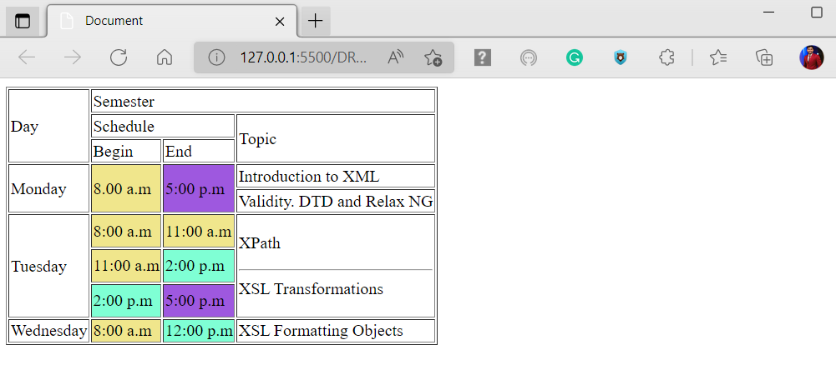

**WEB DEVLOPMENT ASSIGNMENT - 4**

Q1. Write a JavaScript function to capitalize the first letter of each word in string.

*Test Data* :  
(capitalize_Words('js string exercises'));  
"Js String Exercises

<!DOCTYPE html>

<html lang="en">

<head>

<meta charset="UTF-8">

<meta http-equiv="X-UA-Compatible" content="IE=edge">

<meta name="viewport" content="width=device-width, initial-scale=1.0">

<title>Document</title>

<script>

function change(){

var str=document.getElementById("st").value;

var str1=str.split(" ");

for(i=0;i<str1.length;i++){

str1[i]=str1[i].charAt(0).toUpperCase()+str1[i].slice(1)

}

var str3=str1.join(" ");

console.log(str3)

document.getElementById("res").value=str3;

}

</script>

</head>

<body>

Enter string<input type="text" name="" id="st"><br>

Result<input type="text" name="" id="res"><br>

<input type="button" name="" id="bt" value="Title" onclick="change()" />

</body>

</html>

**Output**

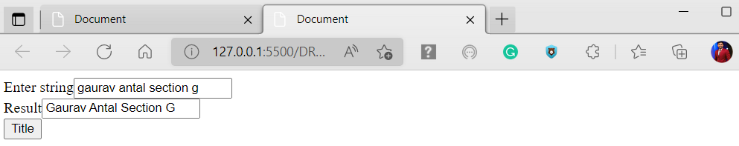

Q2. Write a JavaScript function that takes a string which has lower and upper case letters as a parameter and converts upper case letters to lower case, and lower case letters to upper case.

*Test Data* :  
(swapcase('AaBbc'));  
"aAbBC"

<!DOCTYPE html>

<html>

<body>

<script>

function swap_case() {

str = document.getElementById("string").value;

res = '';

for (var i = 0; i < str.length; ++i) {

c = str[i];

if (c == c.toUpperCase())

res += c.toLowerCase();

else if (c == c.toLowerCase())

res += c.toUpperCase();

else

res += c;

}

document.getElementById("ans").value = res;

}

</script>

Enter the word here: <input id="string">

Ans <input id="ans">

<input type="button" onclick="swap_case()" value="SwapCase" >

</body>

</html>

**Output**

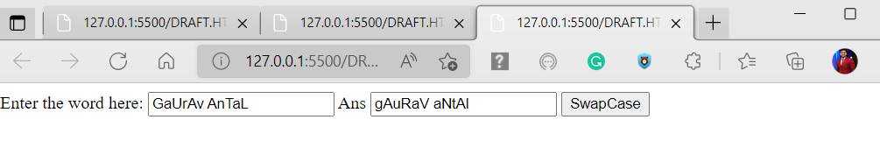

Q3.Develop and demonstrate a HTML file that includes JavaScript script that uses functions for the following problems:

a) Parameter: A string

Output: The position in the string of the left-most vowel

b)Parameter: A number

Output: The number with its digits in the reverse order.

<!DOCTYPE html>

<html >

<body>

<script>

function leftMostVowel(){

var s = document.getElementById("first").value;

for(var i = 0 ; i < s.length ; i++ ){

var c = s.charAt(i).toLowerCase();

if(c == 'a' || c == 'e' || c == 'i' || c == 'o' || c == 'u'){

document.getElementById("ans").value = c;

break;

}

}

}

function rev(){

var a = document.getElementById("sec").value;

var b = a.split("");

b.reverse();

a = b.join("");

document.getElementById("ans1").value = a;

}

</script>

<table>

<tr>

<td>Enter the word here: </td>

<td><input id="first"></td>

<td>Ans <input id="ans"></td>

<td><input type="button" onclick="leftMostVowel()" value="Vowel" /></td>

</tr>

<tr>

<td>Enter the number:</td>

<td><input id="sec"></td>

<td>Rev <input id="ans1"></td>

<td><input type="button" onclick="rev()" value="Reverse" /></td>

</tr>

</table>

</body>

</html>

**Output**

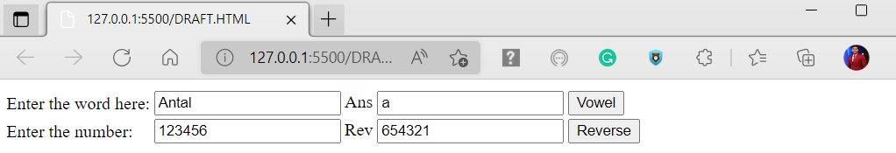

Q4: Write a JavaScript function that takes a string as a parameter and  
count occurrence of each alphabet in a given string.

<!DOCTYPE html>

<html lang="en">

<head>

<meta charset="UTF-8">

<meta http-equiv="X-UA-Compatible" content="IE=edge">

<meta name="viewport" content="width=device-width, initial-scale=1.0">

<title>Document</title>

<script>

function fun() {

var str = document.getElementById("x").value;

str.toLowerCase();

var arr = {};

for (i = 0; i < str.length; i++) {

if (arr[str[i]]) {

arr[str[i]]++;

}

else {

arr[str[i]] = 1;

}

}

var s="";

for (i = 0; i < str.length; i++) {

if (arr[str[i]] != 0) {

s+=str[i] + "->" + arr[str[i]] + "times" + " ";

document.getElementById("p").innerHTML=s;

arr[str[i]]=0;

}

}

}

</script>

</head>

<body>

Enter the word here <input type="text" name="" id="x">

<input type="button" name="" id="" value="Occur" onclick="fun()">

<p id="p"></p>

</body>

</html>

**Output**

**WEB DEVLOPMENT ASSIGNMENT - 5**

Q1. Write a JavaScript function to chop a string into chunks of a given length

Test Data :  
console.log(string_chop('welcome'));  
console.log(string_chop('welcome',2));  
console.log(string_chop('welcome',3));  
["welcome"]  
["we", "lc", "om", "e"]  
["wel", "com", "e"]

<!DOCTYPE html>

<html lang="en">

<head>

<meta charset="UTF-8">

<meta http-equiv="X-UA-Compatible" content="IE=edge">

<meta name="viewport" content="width=device-width, initial-scale=1.0">

<title>Document</title>

<script>

function string_chop(str,n){

var arr=[];

for(i=0;i<str.length;i+=n){

arr.push(str.substr(i,n));

}

return arr;

}

console.log(string_chop("welcome"));

console.log(string_chop("welcome",2));

</script>

</head>

<body>

</body>

</html>

**Output**

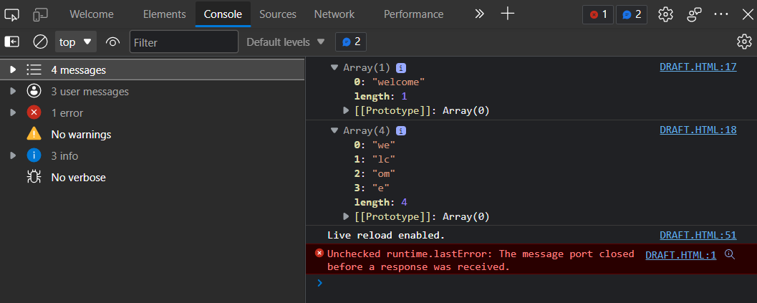

Q2. Write a JavaScript function to convert a string to title case.  
Test Data :  
console.log(sentenceCase('hoW aRe YOU'));  
"How Are You"

<!DOCTYPE html>

<html lang="en">

<head>

<meta charset="UTF-8">

<meta http-equiv="X-UA-Compatible" content="IE=edge">

<meta name="viewport" content="width=device-width, initial-scale=1.0">

<title>Document</title>

<script>

function change(){

var str=document.getElementById("st").value;

var str1=str.split(" ");

for(i=0;i<str1.length;i++){

str1[i]=str1[i].charAt(0).toUpperCase()+(str1[i].slice(1).toLowerCase());

}

var str3=str1.join(" ");

console.log(str3)

document.getElementById("res").value=str3;

}

</script>

</head>

<body>

Enter string<input type="text" name="" id="st"><br>

Result<input type="text" name="" id="res"><br>

<input type="button" name="" id="bt" value="Title" onclick="change()" />

</body>

</html>

**Output**

Q3.

<!DOCTYPE html>

<html lang="en">

<head>

<meta charset="UTF-8">

<meta http-equiv="X-UA-Compatible" content="IE=edge">

<meta name="viewport" content="width=device-width, initial-scale=1.0">

<title>Document</title>

<script>

function check() {

var x = parseInt(document.getElementById("n1").value);

if (x < 2 || x > 100)

document.getElementById("p").innerHTML = "Number Out of range";

else {

var result = x.toString(2);

var count = 0;

for (i = 0; i < result.length; i++) {

if (result[i] == '1')

count++;

}

if (count % 2 == 0)

document.getElementById("p").innerHTML = "Evil Number";

else

document.getElementById("p").innerHTML = "Not Evil Number";

}

}

</script>

</head>

<body>

Number<input type="text" name="" id="n1" />

<p id="p"></p>

<input type="button" name="" value="Check " id="" onclick="check()">

</body>

</html>

**Output**

Que : Develop a PHP Script for sum of digits, check if palindrome and display current datetime.

<html>

<head></head>

<body>

<formaction="que9.php"method="post">

Enter the number : <inputtype="number"value=""name="num"required>

<br>

<inputtype="submit"value="submit"name="submit">

</form>

<?php

if(isset($_POST["submit"])){

$num2=$num1=$num=$_POST["num"];

$rem=0;

$sum=0;

$temp=$num;

for ($i =0; $i<=strlen($num);$i++)

{

$rem=$temp%10;

$sum = $sum + $rem;

$temp=$temp/10;

}

echo"Sum of digits is $sum";

echo"<br>";

$test=strval($num1);

if(strrev($test)==$num1){

echo"palindrome";

echo"<br>";

}

else{

echo"not a palindrome";

echo"<br>";

}

//Date

$t=time();

echo(date("Y-m-d h:i:s:a",$t));

}

?>

</body>

</html>

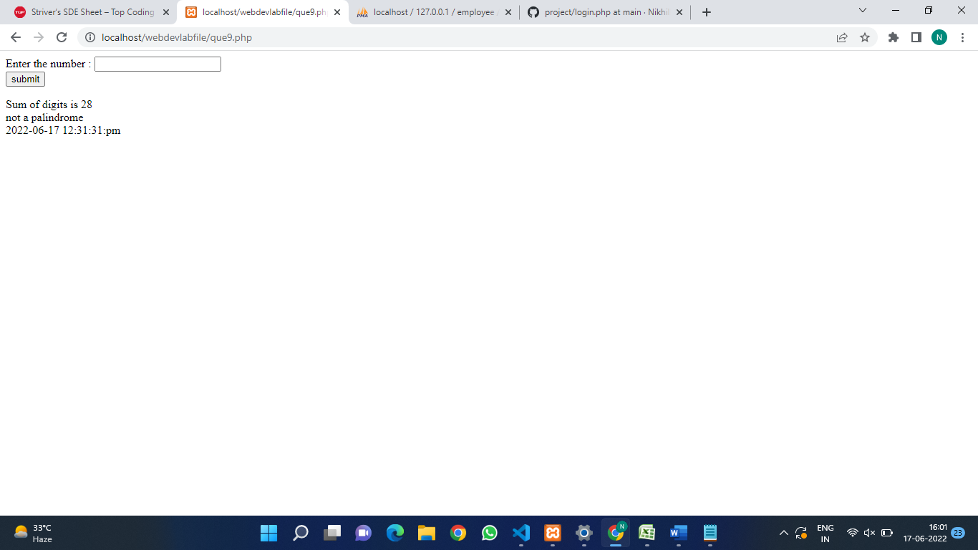

Que : Form validation using PHP

<!DOCTYPEHTML>

<html>

<head>

<style>

.error {color: #FF0000;

}

p{

text-align:center;

}

.f{

text-align:center;

border:orange;

border-width:5px;

border-style:solid;

padding-top:40px;

padding-bottom:40px;

margin-left:347px;

margin-right:347px;

}

h2{

text-align:center;

}

</style>

</head>

<body>

<?php

// define variables and set to empty values

$nameErr = $emailErr = $genderErr ="";

$name = $email = $gender = $comment ="";

if ($_SERVER["REQUEST_METHOD"] =="POST") {

if (empty($_POST["name"])) {

$nameErr ="Name is required";

} else {

$name =test_input($_POST["name"]);

// check if name only contains letters and whitespace

if (!preg_match("/^[a-zA-Z ]*$/",$name)) {

$nameErr ="Only letters and white space allowed";

}

}

if (empty($_POST["email"])) {

$emailErr ="Email is required";

} else {

$email =test_input($_POST["email"]);

// check if e-mail address is well-formed

if (!filter_var($email, FILTER_VALIDATE_EMAIL)) {

$emailErr ="Invalid email format";

}

}

if (empty($_POST["comment"])) {

$comment ="";

} else {

$comment =test_input($_POST["comment"]);

}

if (empty($_POST["gender"])) {

$genderErr ="Gender is required";

} else {

$gender =test_input($_POST["gender"]);

}

}

functiontest_input($data) {

$data =trim($data);

$data =stripslashes($data);

$data =htmlspecialchars($data);

return $data;

}

?>

<h2>PHP Form Validation Example</h2>

<p><spanclass="error">* required field</span></p>

<formclass="f"method="post"action="<?php echohtmlspecialchars($_SERVER["PHP_SELF"]);?>">

Name: <inputtype="text"name="name">

<spanclass="error">* <?php echo $nameErr;?></span>

<br><br>

E-mail: <inputtype="text"name="email">

<spanclass="error">* <?php echo $emailErr;?></span>

<br><br>

Comment: <textareaname="comment"rows="5"cols="40"></textarea>

<br><br>

Gender:

<inputtype="radio"name="gender"value="female">Female

<inputtype="radio"name="gender"value="male">Male

<inputtype="radio"name="gender"value="other">Other

<spanclass="error">* <?php echo $genderErr;?></span>

<br><br>

<inputtype="submit"name="submit"value="Submit">

</form>

<?php

echo"<h2>Your Input:</h2>";

echo $name;

echo"<br>";

echo $email;

echo"<br>";

echo $comment;

echo"<br>";

echo $gender;

?>

</body>

</html>

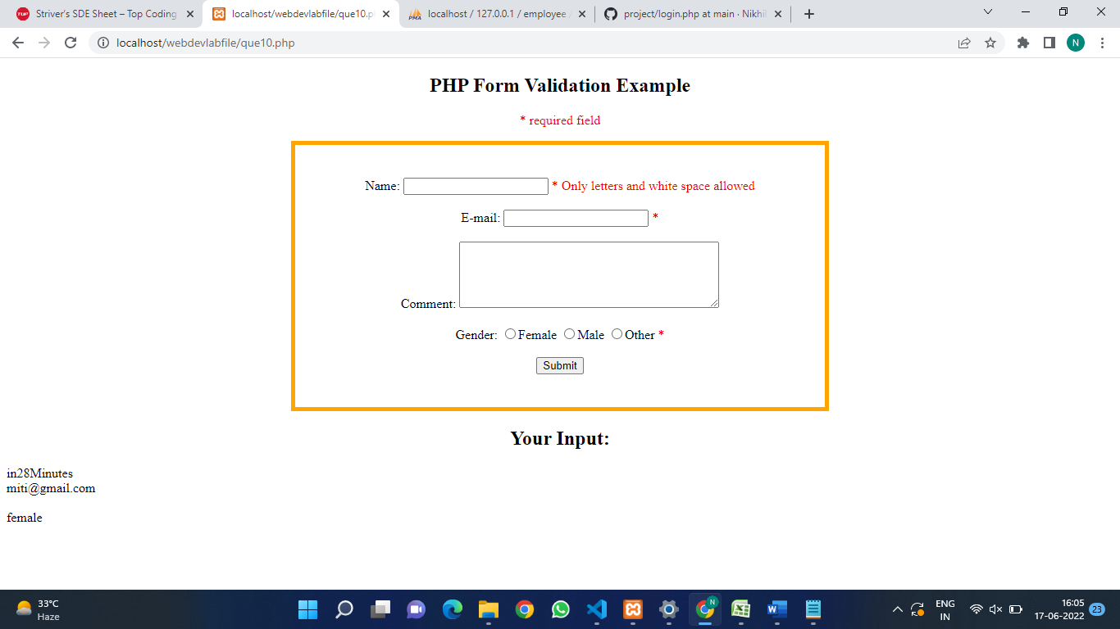

Que :Write a PHP program to store page views count in SESSION, to increment the count on each refresh, and to show the count on web page.

<!DOCTYPEhtml>

<htmllang="en">

<head>

<metacharset="UTF-8">

<metahttp-equiv="X-UA-Compatible"content="IE=edge">

<metaname="viewport"content="width=device-width, initial-scale=1.0">

<title>Document</title>

</head>

<body>

<?php

session_start();

$_SESSION["counter"]=$_SESSION["counter"]+1;

?>

<h2>Code to count no of session or page views</h2>

<?php

echo"Session Count : ".$_SESSION["counter"];

?>

</body>

</html>

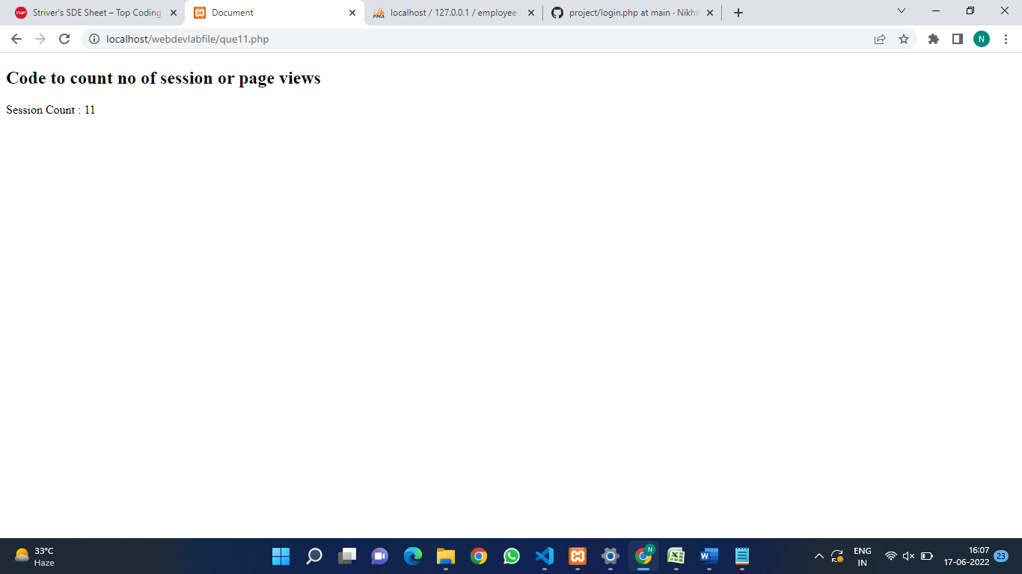

Que : Create an HTML form and the write a PHP code for inserting the employee information in database. Information includes employee name, address, phone number, email id, salary etc.

<?php

$user='root';

$pass='';

$db='Employee';

$con=mysqli_connect('localhost',$user,$pass,$db) or

die("connection failed".mysqli_connect_error());

echo"connected successfully";

$name = $_POST["name"];

$email = $_POST["email"];

$address = $_POST["address"];

$phone = $_POST["phone"];

$salary = $_POST['salary'];

$sql=insertintodetails (name, email, address, phone, salary) VALUES ('$name', '$email', '$address', $phone, $salary);

$result=mysqli_query($con, $sql);

if($result)

echo"inserted successfully";

else{

echo"not inserted ";

}

?>

<!DOCTYPEhtml>

<htmllang="en">

<head>

<metacharset="UTF-8">

<metahttp-equiv="X-UA-Compatible"content="IE=edge">

<metaname="viewport"content="width=device-width, initial-scale=1.0">

<title>Document</title>

</head>

<body>

<formclass="form-inner"action="que12.php"method="post">

Employee name: <inputtype="text"value=""placeholder ="Enter Employee Name"name="name"required>

<br>

Employee Email: <inputtype="email"value=""placeholder ="Enter Employee Email"name="email"required>

<br>

Address: <inputtype="text"value=""placeholder ="Enter Address"name="address"required>

<br>

Contact No.: <inputtype="number"value=""placeholder ="Enter Contact Details"name="phone"maxlength="10"required>

<br>

<inputtype="submit"value="submit">

</form>

</body>

</html>

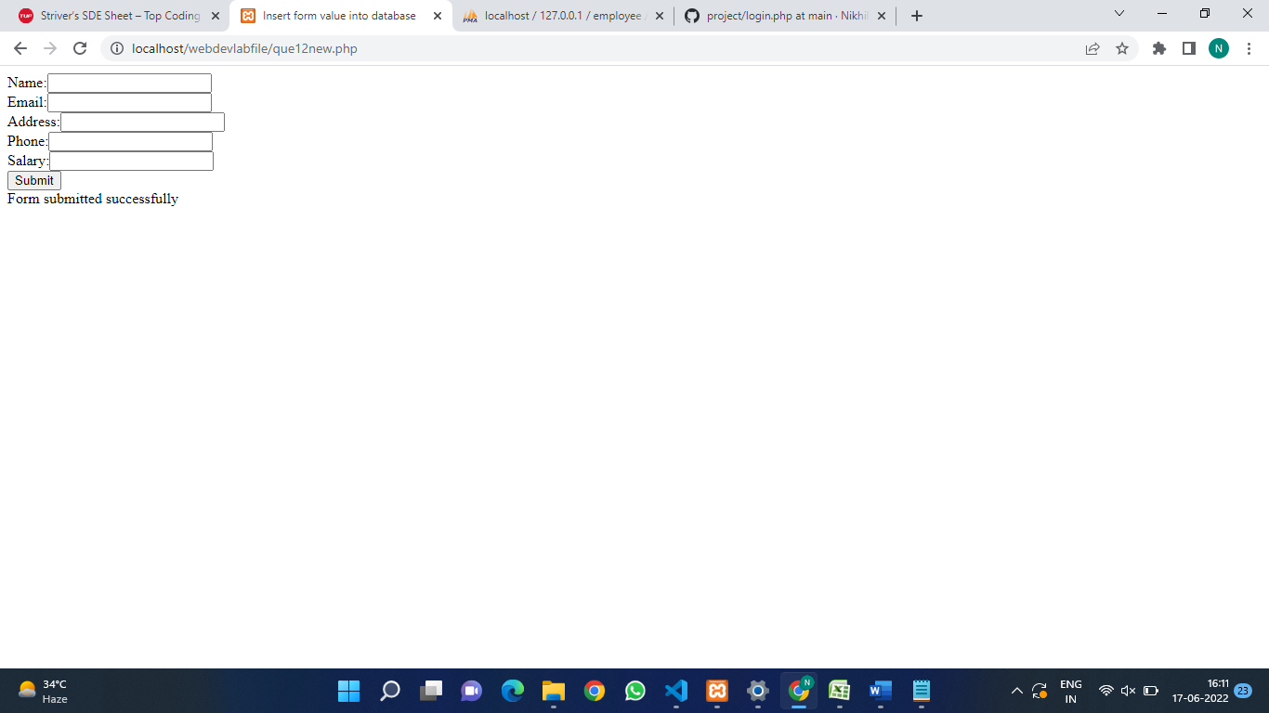

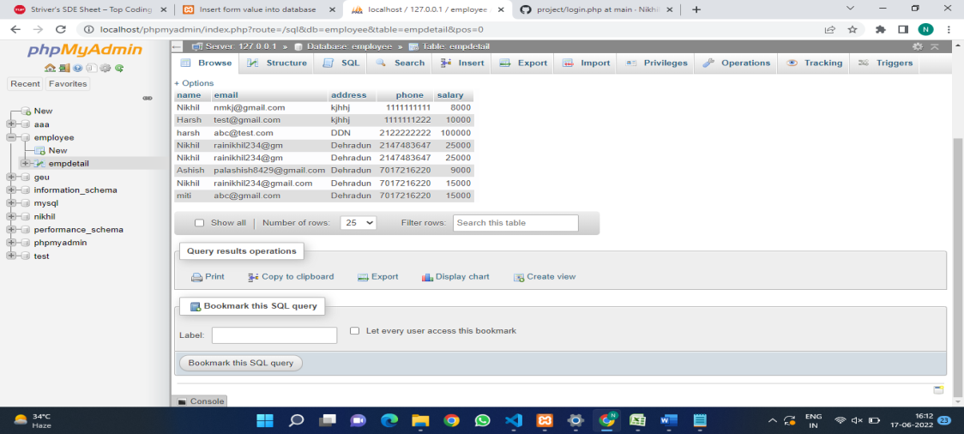

Que : Fetch details from a database

<html>

<head></head>

<body>

<?php

$user='root';

$pass='';

$db='employee';

$con=mysqli_connect('localhost',$user,$pass,$db) or

die("connection failed".mysqli_connect_error());

$sql="SELECT*from empdetail where salary<10000";

$result=mysqli_query($con,$sql);

if(mysqli_num_rows($result)>0){

while($row =mysqli_fetch_assoc($result)) {

echo"name: ". $row["name"]." - Email: ". $row["email"]." - Address: ". $row["address"]. " - Phone Number: ". $row["phone"]." - Salary: ". $row["salary"]."<br>";

}

}elseecho"0 Result";

mysqli_close($con);

?>

</body>

</html>

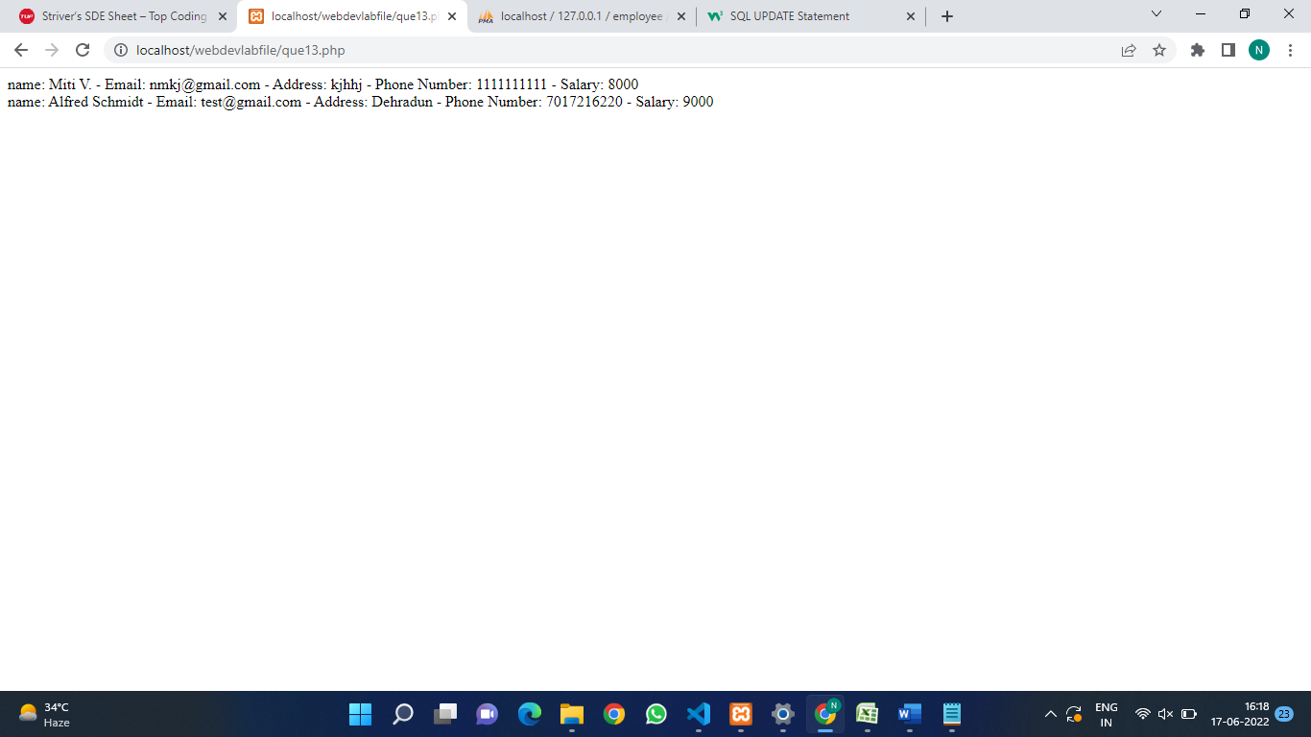

Que : With the help of PHP code insert some text in text file. After inserting the text read the text from the same text file and shows it on web page.

<?php

$mytxt=fopen("web.txt","w")ordie("Unable to read file");

$txt="Hello There! This is a demo text.";

fwrite($mytxt,$txt);

readfile("web.txt");

?>

<!DOCTYPEhtml>

<htmllang="en">

<head>

<metacharset="UTF-8">

<metahttp-equiv="X-UA-Compatible"content="IE=edge">

<metaname="viewport"content="width=device-width, initial-scale=1.0">

<title>Document</title>

</head>

<body>

<h3>This is a demo web page!</h3>

<?php

?>

</body>

</html>

